Software Processes
The term software specifies to the set of computer programs, procedures and associated documents (Flowcharts, manuals, etc.) that describe the program and how they are to be used.
A software process is the set of activities and associated outcome that produce a software product. Software engineers mostly carry out these activities. These are four key process activities, which are common to all software processes. These activities are:
- Software specifications: The functionality of the software and constraints on its operation must be defined.
- Software development: The software to meet the requirement must be produced.
- Software validation: The software must be validated to ensure that it does what the customer wants.
- Software evolution: The software must evolve to meet changing client needs.

Software Development Life Cycle (SDLC)
A software life cycle model (also termed process model) is a pictorial and diagrammatic representation of the software life cycle. A life cycle model represents all the methods required to make a software product transit through its life cycle stages. It also captures the structure in which these methods are to be undertaken.
In other words, a life cycle model maps the various activities performed on a software product from its inception to retirement. Different life cycle models may plan the necessary development activities to phases in different ways. Thus, no element which life cycle model is followed, the essential activities are contained in all life cycle models though the action may be carried out in distinct orders in different life cycle models. During any life cycle stage, more than one activity may also be carried out.

Need of SDLC
The development team must determine a suitable life cycle model for a particular plan and then observe to it.
Without using an exact life cycle model, the development of a software product would not be in a systematic and disciplined manner. When a team is developing a software product, there must be a clear understanding among team representative about when and what to do. Otherwise, it would point to chaos and project failure. This problem can be defined by using an example. Suppose a software development issue is divided into various parts and the parts are assigned to the team members. From then on, suppose the team representative is allowed the freedom to develop the roles assigned to them in whatever way they like. It is possible that one representative might start writing the code for his part, another might choose to prepare the test documents first, and some other engineer might begin with the design phase of the roles assigned to him. This would be one of the perfect methods for project failure.
A software life cycle model describes entry and exit criteria for each phase. A phase can begin only if its stage-entry criteria have been fulfilled. So without a software life cycle model, the entry and exit criteria for a stage cannot be recognized. Without software life cycle models, it becomes tough for software project managers to monitor the progress of the project.

SDLC Cycle
SDLC Cycle represents the process of developing software. SDLC framework includes the following steps:
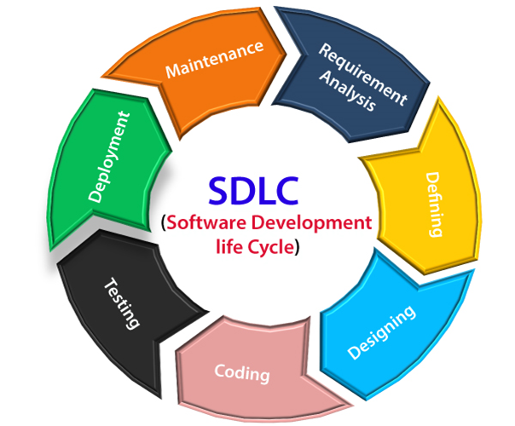

The stages of SDLC are as follows:
Stage1: Planning and requirement analysis
Requirement Analysis is the most important and necessary stage in SDLC.
The senior members of the team perform it with inputs from all the stakeholders and domain experts or SMEs in the industry.
Planning for the quality assurance requirements and identifications of the risks associated with the projects is also done at this stage.
Business analyst and Project organizer set up a meeting with the client to gather all the data like what the customer wants to build, who will be the end user, what is the objective of the product. Before creating a product, a core understanding or knowledge of the product is very necessary.
For Example, A client wants to have an application which concerns money transactions. In this method, the requirement has to be precise like what kind of operations will be done, how it will be done, in which currency it will be done, etc.
Once the required function is done, an analysis is complete with auditing the feasibility of the growth of a product. In case of any ambiguity, a signal is set up for further discussion.
Once the requirement is understood, the SRS (Software Requirement Specification) document is created. The developers should thoroughly follow this document and also should be reviewed by the customer for future reference.
Stage2: Defining Requirements
Once the requirement analysis is done, the next stage is to certainly represent and document the software requirements and get them accepted from the project stakeholders.
This is accomplished through "SRS"- Software Requirement Specification document which contains all the product requirements to be constructed and developed during the project life cycle.
Stage3: Designing the Software
The next phase is about to bring down all the knowledge of requirements, analysis, and design of the software project. This phase is the product of the last two, like inputs from the customer and requirement gathering.
Stage4: Developing the project
In this phase of SDLC, the actual development begins, and the programming is built. The implementation of design begins concerning writing code. Developers have to follow the coding guidelines described by their management and programming tools like compilers, interpreters, debuggers, etc. are used to develop and implement the code.
Stage5: Testing
After the code is generated, it is tested against the requirements to make sure that the products are solving the needs addressed and gathered during the requirements stage.
During this stage, unit testing, integration testing, system testing, acceptance testing are done.
Stage6: Deployment
Once the software is certified, and no bugs or errors are stated, then it is deployed.
Then based on the assessment, the software may be released as it is or with suggested enhancement in the object segment.
After the software is deployed, then its maintenance begins.
Stage7: Maintenance
Once when the client starts using the developed systems, then the real issues come up and requirements to be solved from time to time.
This procedure where the care is taken for the developed product is known as maintenance.

Software Development Life Cycle (SDLC) is a process used by the software industry to design, develop and test high quality softwares. The SDLC aims to produce a high-quality software that meets or exceeds customer expectations, reaches completion within times and cost estimates.
- SDLC is the acronym of Software Development Life Cycle.
- It is also called as Software Development Process.
- SDLC is a framework defining tasks performed at each step in the software development process.
- ISO/IEC 12207 is an international standard for software life-cycle processes. It aims to be the standard that defines all the tasks required for developing and maintaining software.

What is SDLC?
SDLC is a process followed for a software project, within a software organization. It consists of a detailed plan describing how to develop, maintain, replace and alter or enhance specific software. The life cycle defines a methodology for improving the quality of software and the overall development process.
The following figure is a graphical representation of the various stages of a typical SDLC.
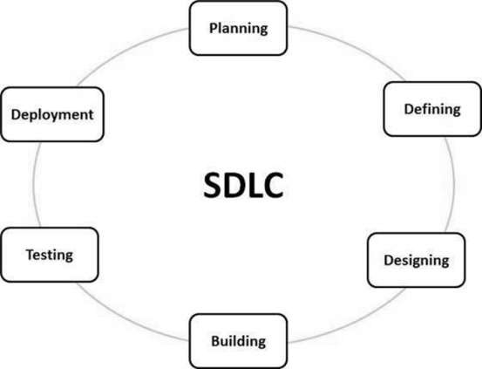
A typical Software Development Life Cycle consists of the following stages −

Stage 1: Planning and Requirement Analysis
Requirement analysis is the most important and fundamental stage in SDLC. It is performed by the senior members of the team with inputs from the customer, the sales department, market surveys and domain experts in the industry. This information is then used to plan the basic project approach and to conduct product feasibility study in the economical, operational and technical areas.
Planning for the quality assurance requirements and identification of the risks associated with the project is also done in the planning stage. The outcome of the technical feasibility study is to define the various technical approaches that can be followed to implement the project successfully with minimum risks.

Stage 2: Defining Requirements
Once the requirement analysis is done the next step is to clearly define and document the product requirements and get them approved from the customer or the market analysts. This is done through an SRS (Software Requirement Specification) document which consists of all the product requirements to be designed and developed during the project life cycle.

Stage 3: Designing the Product Architecture
SRS is the reference for product architects to come out with the best architecture for the product to be developed. Based on the requirements specified in SRS, usually more than one design approach for the product architecture is proposed and documented in a DDS - Design Document Specification.
This DDS is reviewed by all the important stakeholders and based on various parameters as risk assessment, product robustness, design modularity, budget and time constraints, the best design approach is selected for the product.
A design approach clearly defines all the architectural modules of the product along with its communication and data flow representation with the external and third party modules (if any). The internal design of all the modules of the proposed architecture should be clearly defined with the minutest of the details in DDS.

Stage 4: Building or Developing the Product
In this stage of SDLC the actual development starts and the product is built. The programming code is generated as per DDS during this stage. If the design is performed in a detailed and organized manner, code generation can be accomplished without much hassle.
Developers must follow the coding guidelines defined by their organization and programming tools like compilers, interpreters, debuggers, etc. are used to generate the code. Different high level programming languages such as C, C++, Pascal, Java and PHP are used for coding. The programming language is chosen with respect to the type of software being developed.

Stage 5: Testing the Product
This stage is usually a subset of all the stages as in the modern SDLC models, the testing activities are mostly involved in all the stages of SDLC. However, this stage refers to the testing only stage of the product where product defects are reported, tracked, fixed and retested, until the product reaches the quality standards defined in the SRS.

Stage 6: Deployment in the Market and Maintenance
Once the product is tested and ready to be deployed it is released formally in the appropriate market. Sometimes product deployment happens in stages as per the business strategy of that organization. The product may first be released in a limited segment and tested in the real business environment (UAT- User acceptance testing).
Then based on the feedback, the product may be released as it is or with suggested enhancements in the targeting market segment. After the product is released in the market, its maintenance is done for the existing customer base.

SDLC Models
There are various software development life cycle models defined and designed which are followed during the software development process. These models are also referred as Software Development Process Models". Each process model follows a Series of steps unique to its type to ensure success in the process of software development.
Following are the most important and popular SDLC models followed in the industry −
- Waterfall Model
- Iterative Model
- Spiral Model
- V-Model
- Big Bang Model
Other related methodologies are Agile Model, RAD Model, Rapid Application Development and Prototyping Models.

What is a software process model? Top 7 models explained
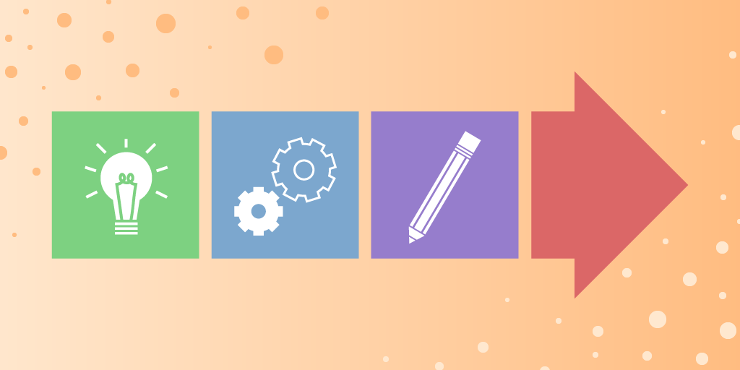
Software processes are the activities for designing, implementing, and testing a software system. The software development process is complicated and involves a lot more than technical knowledge.
That’s where software process models come in handy. A software process model is an abstract representation of the development process.
In this article, we will introduce you to the top seven software process models and discuss when to use them.
We will learn the following:
- What is a software process model?
- Factors in choosing a software process
- Types of software process models

Get hands-on with system design.
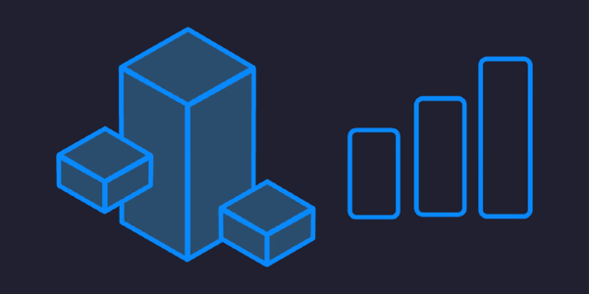
Scalability & System Design for Developers
As you progress in your career as a developer, you'll be increasingly expected to think about software architecture. Can you design systems and make trade-offs at scale? Developing that skill is a great way to set yourself apart from the pack. In this Skill Path, you'll cover everything you need to know to design scalable systems for enterprise-level software.

What is a software process model?
A software process model is an abstraction of the software development process. The models specify the stages and order of a process. So, think of this as a representation of the order of activities of the process and the sequence in which they are performed.
A model will define the following:
- The tasks to be performed
- The input and output of each task
- The pre and post-conditions for each task
- The flow and sequence of each task
The goal of a software process model is to provide guidance for controlling and coordinating the tasks to achieve the end product and objectives as effectively as possible.
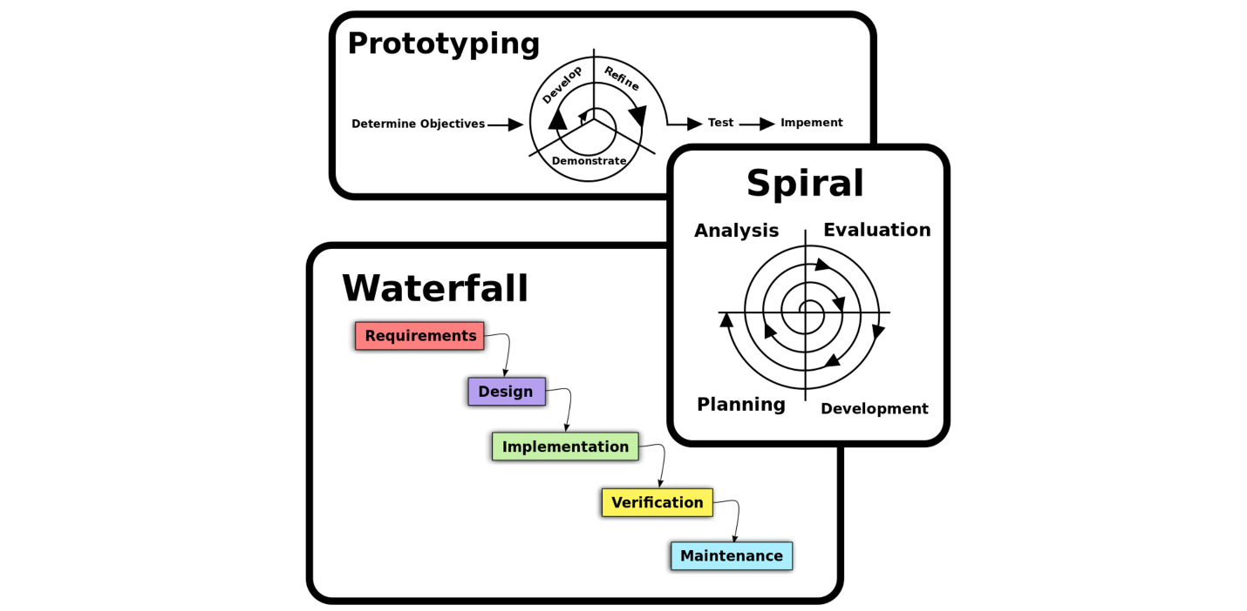
Source: Omar Elgabry
There are many kinds of process models for meeting different requirements. We refer to these as SDLC models (Software Development Life Cycle models). The most popular and important SDLC models are as follows:
- Waterfall model
- V model
- Incremental model
- RAD model
- Agile model
- Iterative model
- Prototype model
- Spiral model

Factors in choosing a software process
Choosing the right software process model for your project can be difficult. If you know your requirements well, it will be easier to select a model that best matches your needs. You need to keep the following factors in mind when selecting your software process model:

Project requirements
Before you choose a model, take some time to go through the project requirements and clarify them alongside your organization’s or team’s expectations. Will the user need to specify requirements in detail after each iterative session? Will the requirements change during the development process?

Project size
Consider the size of the project you will be working on. Larger projects mean bigger teams, so you’ll need more extensive and elaborate project management plans.

Project complexity
Complex projects may not have clear requirements. The requirements may change often, and the cost of delay is high. Ask yourself if the project requires constant monitoring or feedback from the client.

Cost of delay
Is the project highly time-bound with a huge cost of delay, or are the timelines flexible?

Customer involvement
Do you need to consult the customers during the process? Does the user need to participate in all phases?

Familiarity with technology
This involves the developers’ knowledge and experience with the project domain, software tools, language, and methods needed for development.

Project resources
This involves the amount and availability of funds, staff, and other resources.

Get hands-on with system design.
Scalability & System Design for Developers
As you progress in your career as a developer, you'll be increasingly expected to think about software architecture. Can you design systems and make trade-offs at scale? Developing that skill is a great way to set yourself apart from the pack. In this Skill Path, you'll cover everything you need to know to design scalable systems for enterprise-level software.
Software Processes is a coherent set of activities for specifying, designing, implementing and testing software systems. A software process model is an abstract representation of a process that presents a description of a process from some particular perspective. There are many different software processes but all involve:
- Specification – defining what the system should do;
- Design and implementation – defining the organization of the system and implementing the system;
- Validation – checking that it does what the customer wants;
- Evolution – changing the system in response to changing customer needs.

Types of Software Process Model
Software processes, methodologies and frameworks range from specific prescriptive steps that can be used directly by an organization in day-to-day work, to flexible frameworks that an organization uses to generate a custom set of steps tailored to the needs of a specific project or group. In some cases a “sponsor” or “maintenance” organization distributes an official set of documents that describe the process.
Software Process and Software Development Lifecycle Model
One of the basic notions of the software development process is SDLC models which stands for Software Development Life Cycle models. There are many development life cycle models that have been developed in order to achieve different required objectives. The models specify the various stages of the process and the order in which they are carried out. The most used, popular and important SDLC models are given below:
- Waterfall model
- V model
- Incremental model
- RAD model
- Agile model
- Iterative model
- Spiral model
- Prototype model

Waterfall Model
The waterfall model is a breakdown of project activities into linear sequential phases, where each phase depends on the deliverables of the previous one and corresponds to a specialisation of tasks. The approach is typical for certain areas of engineering design.
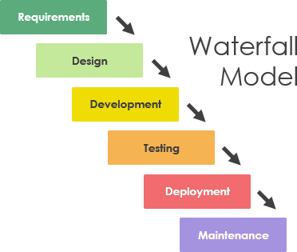

V Model
The V-model represents a development process that may be considered an extension of the waterfall model and is an example of the more general V-model. Instead of moving down in a linear way, the process steps are bent upwards after the coding phase, to form the typical V shape. The V-Model demonstrates the relationships between each phase of the development life cycle and its associated phase of testing. The horizontal and vertical axes represent time or project completeness (left-to-right) and level of abstraction (coarsest-grain abstraction uppermost), respectively.
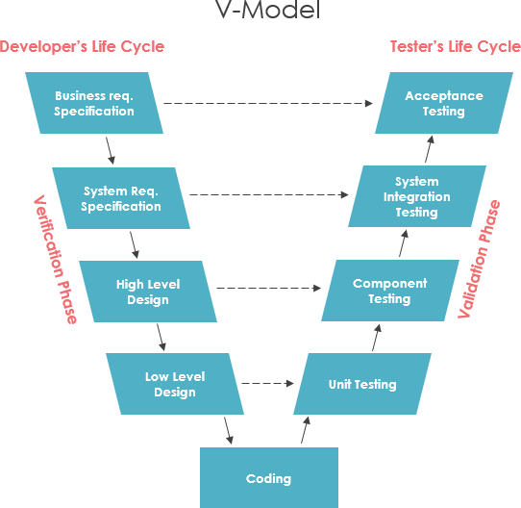

Incremental model
The incremental build model is a method of software development where the model is designed, implemented and tested incrementally (a little more is added each time) until the product is finished. It involves both development and maintenance. The product is defined as finished when it satisfies all of its requirements. Each iteration passes through the requirements, design, coding and testing phases. And each subsequent release of the system adds function to the previous release until all designed functionally has been implemented. This model combines the elements of the waterfall model with the iterative philosophy of prototyping.
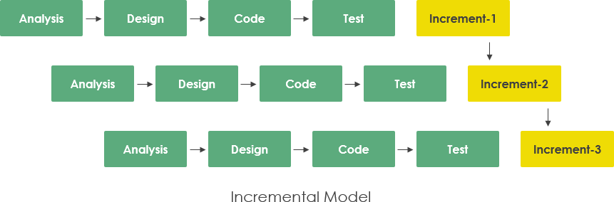

Iterative Model
An iterative life cycle model does not attempt to start with a full specification of requirements by first focusing on an initial, simplified set user features, which then progressively gains more complexity and a broader set of features until the targeted system is complete. When adopting the iterative approach, the philosophy of incremental development will also often be used liberally and interchangeably.
In other words, the iterative approach begins by specifying and implementing just part of the software, which can then be reviewed and prioritized in order to identify further requirements. This iterative process is then repeated by delivering a new version of the software for each iteration. In a light-weight iterative project the code may represent the major source of documentation of the system; however, in a critical iterative project a formal software specification may also be required.
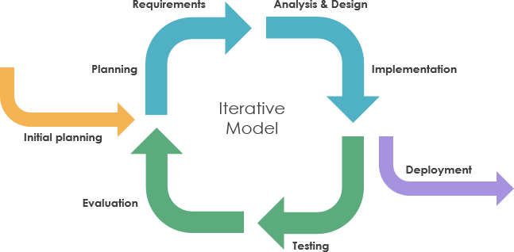

RAD model
Rapid application development was a response to plan-driven waterfall processes, developed in the 1970s and 1980s, such as the Structured Systems Analysis and Design Method (SSADM). Rapid application development (RAD) is often referred as the adaptive software development. RAD is an incremental prototyping approach to software development that end users can produce better feedback when examining a live system, as opposed to working strictly with documentation. It puts less emphasis on planning and more emphasis on an adaptive process.
RAD may resulted in a lower level of rejection when the application is placed into production, but this success most often comes at the expense of a dramatic overruns in project costs and schedule. RAD approach is especially well suited for developing software that is driven by user interface requirements. Thus, some GUI builders are often called rapid application development tools.
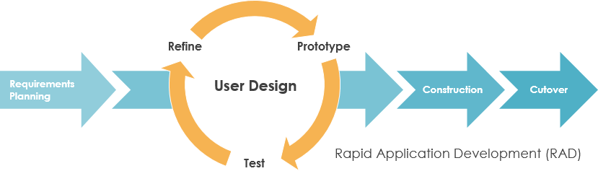

Spiral model
The spiral model, first described by Barry Boehm in 1986, is a risk-driven software development process model which was introduced for dealing with the shortcomings in the traditional waterfall model. A spiral model looks like a spiral with many loops. The exact number of loops of the spiral is unknown and can vary from project to project. This model supports risk handling, and the project is delivered in loops. Each loop of the spiral is called a Phase of the software development process.
The initial phase of the spiral model in the early stages of Waterfall Life Cycle that is needed to develop a software product. The exact number of phases needed to develop the product can be varied by the project manager depending upon the project risks. As the project manager dynamically determines the number of phases, so the project manager has an important role to develop a product using a spiral model.
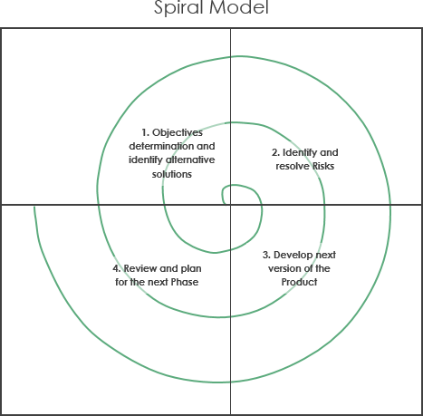

Agile model
Agile is an umbrella term for a set of methods and practices based on the values and principles expressed in the Agile Manifesto that is a way of thinking that enables teams and businesses to innovate, quickly respond to changing demand, while mitigating risk. Organizations can be agile using many of the available frameworks available such as Scrum, Kanban, Lean, Extreme Programming (XP) and etc.
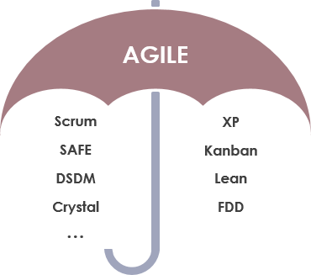
The Agile movement proposes alternatives to traditional project management. Agile approaches are typically used in software development to help businesses respond to unpredictability which refer to a group of software development methodologies based on iterative development, where requirements and solutions evolve through collaboration between self-organizing cross-functional teams.
The primary goal of being Agile is empowered the development team the ability to create and respond to change in order to succeed in an uncertain and turbulent environment. Agile software development approach is typically operated in rapid and small cycles. This results in more frequent incremental releases with each release building on previous functionality. Thorough testing is done to ensure that software quality is maintained.
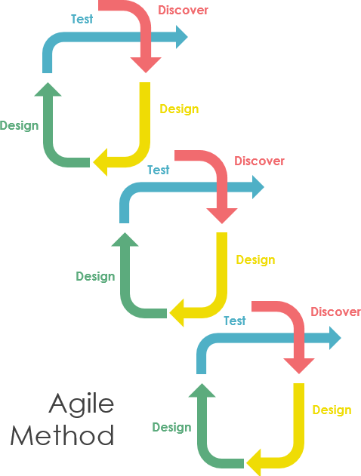

Managing Software Process with Visual Paradigm
Visual Paradigm provides a rich set of project management tools that help software team perform major development activities and manage the artifact created throughout the process.

Project Manage Guide-Through
Kick-start any size of IT projects with automated guide-through process, with step-by-step instruction, input references and samples. Develop deliverables incrementally and collaboratively with your team members.
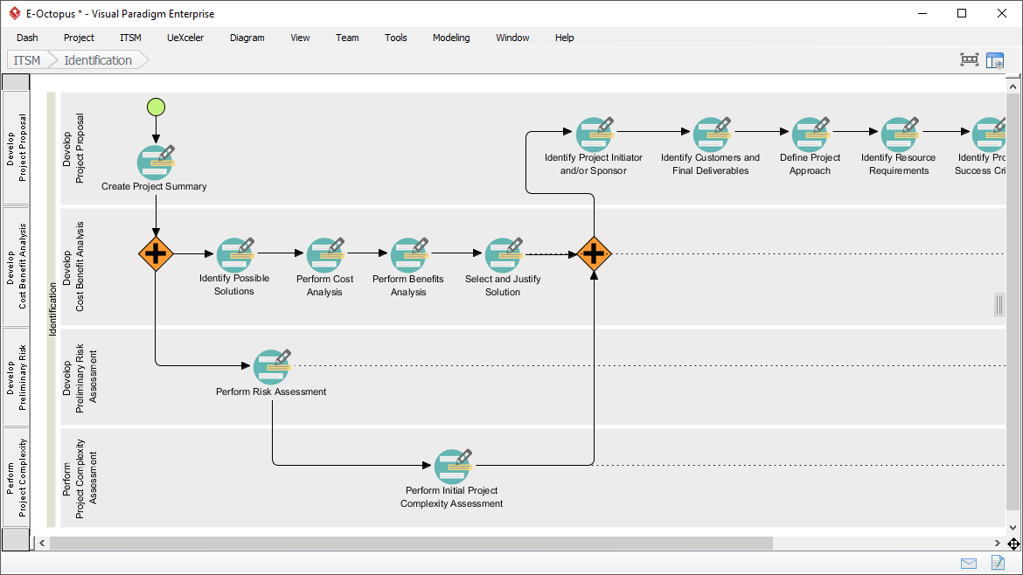

Just-in-Time PMBOK / Project Management Process Map
People are facing great deal of difficulties on Project Management such as steep learning curve and high costs hiring certified professionals. Visual Paradigm’s unique automated PMBOK tool provides all the help and guidance for jumpstarting IT project management with minimal costs.
